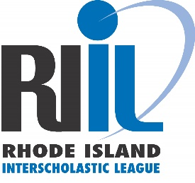

FOR IMMEDIATE RELEASE

WARWICK, RI (SEPTEMBER 26, 2019) - In response to several incidents that have occurred this school year, the Rhode Island Interscholastic League is issuing the following statement:
As part of its ongoing point of emphasis, the Rhode Island Interscholastic League Principals’ Committee on Athletics has been and is committed to promoting good sportsmanship at all member high school athletic contests throughout the regular season and playoffs. Specifically, the PCOA is concerned with recent incidents of improper behavior of student athletes and coaches on the field or court and the ever-increasing unsportsmanlike behavior of spectators.
The RIIL Principals’ Committee on Athletics reminds all of its member schools and leagues that it is essential to have clearly defined and articulated standards of sportsmanship which are enforced at all levels of play. Those standards should align with the Standards outlined in Article 12 of the RIIL Rules and Regulations (https://www.riil.org/page/3042) and should be published in the student athlete/parent handbook, as well as other documents and publications provided by the school. Expectations for spectators should be communicated, enforced, and announced when appropriate.
The Objectives of Good Sportsmanship:
- Encourage all coaches, players and spectators to exhibit good sportsmanship
- Develop a set of standards identifying what good sportsmanship is
- Identify who is responsible for promoting good sportsmanship
- Identify ways to enforce good sportsmanship
It is the RIIL’s expectation that the home school provide a welcoming, safe, and respectful environment for visiting teams, officials, coaches and fans.
Member schools are responsible for the conduct of spectators at games they are hosting. Spectators whose conduct is abusive to officials, participants or spectators, or that violates reasonable social standards of conduct, should be removed from the game.
The PCOA expects schools and game officials to provide reports/information relating to unsportsmanlike behavior at any RIIL contest.
The league remains committed to its mission to provide high school sports opportunities in an educational, school-based environment and will continue to provide member schools with leadership training, education, and resources to influence positive behavior at all contests. During these difficult times, we need to work collaboratively and tirelessly to change the culture of poor sportsmanship that has plagued our society.
Thomas A. Mezzanotte
Executive Director, Rhode Island Interscholastic League

